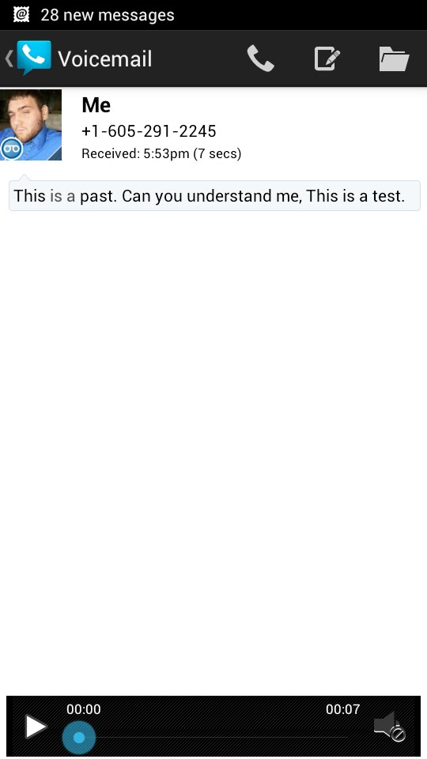

Google Voice to Text

My phone has not been working correctly so I used my husband’s phone.

He already had a Google Voice number for work so I just needed to call and leave a message.

I called twice, once with his phone and once with my loaner phone.

I tried to speak very clear. These are the results I got.

Both transcripts were emailed, texted, and notified through a text.

